Exp. 2. Simulation of Density of States of Quantum Well Structure with Various Nanometer Thickness.
Aim: To simulate density of states of quantum well structure with various nano meter thickness

Case Study 1: Simulate the density of states of quantum well of thickness 0.5 nm
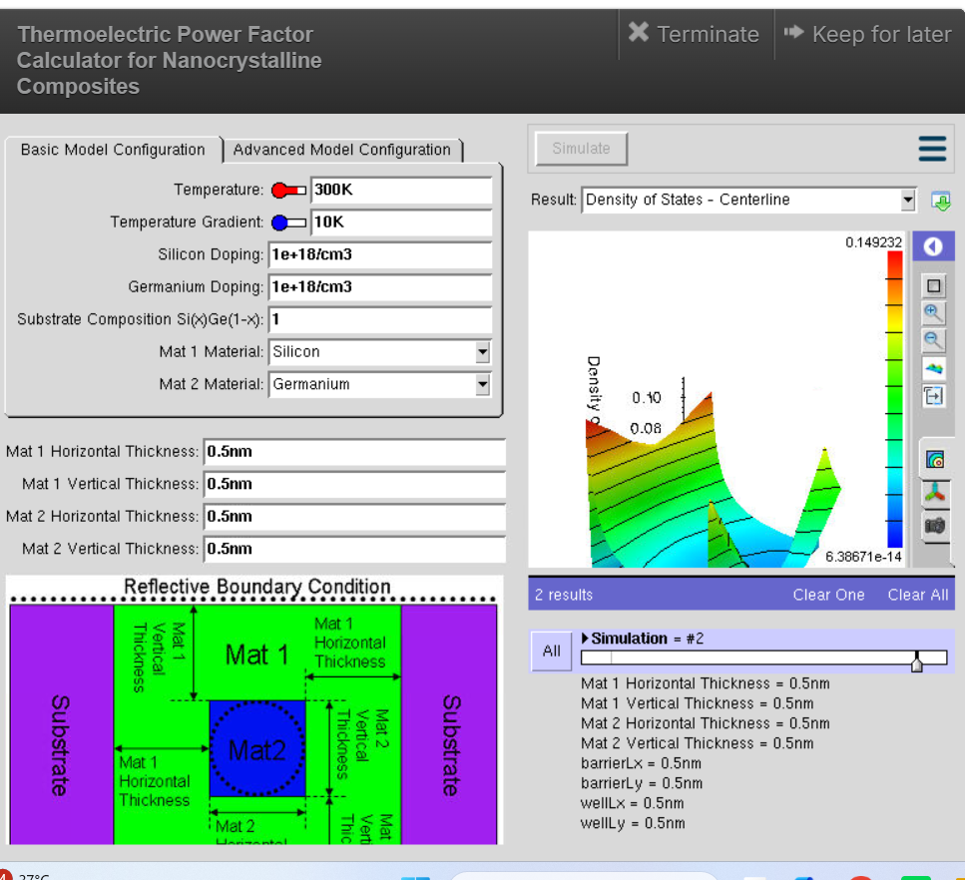
Observation:
- The quantum well thickness was set to 0.5 nm while keeping all other parameters constant (Temperature = 300 K, Temperature Gradient = 10 K, Silicon and Germanium doping = 1 × 10¹⁸ cm⁻³).
- The simulated Density of States (DOS) plot shows sharp and distinct peaks, indicating strong quantum confinement.
- The energy levels are widely separated due to the very thin quantum well.
- Charge carriers are confined to a smaller region, resulting in discrete energy states rather than continuous bands.
- The DOS distribution changes rapidly with energy, indicating significant quantization effects.
Case Study 2: Simulate the density of states of quantum well of thickness 0.6 nm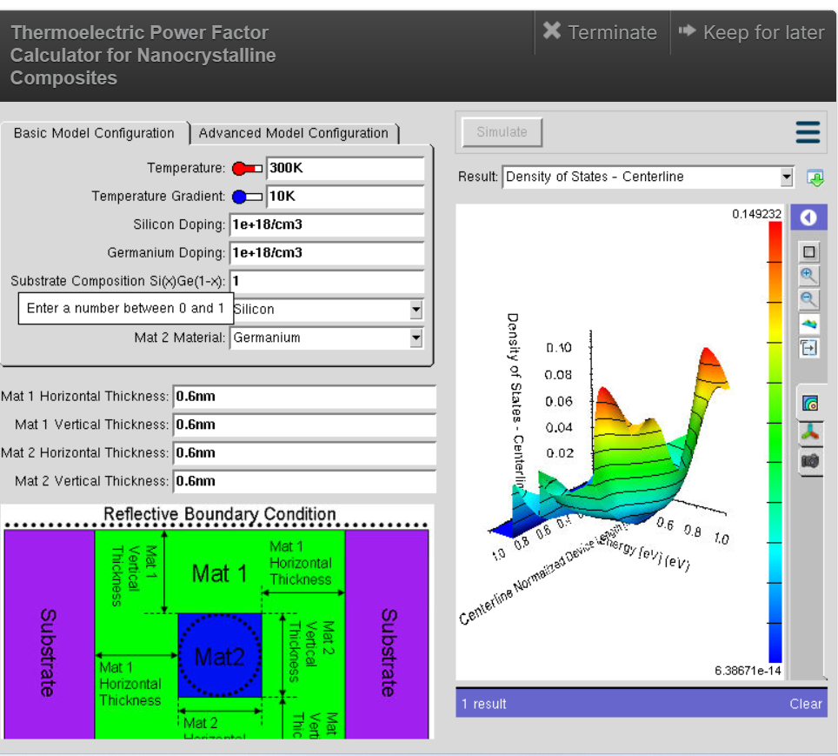
Observation:
- The quantum well thickness was increased to 0.6 nm, while all other simulation parameters remained unchanged.
- The DOS graph shows broader and smoother peaks compared to the 0.5 nm case.
- The spacing between quantized energy levels decreases because the wider quantum well reduces quantum confinement.
- More energy states become available for carrier occupation, leading to a smoother DOS profile.
- Carrier confinement is slightly weaker than in the 0.5 nm structure.

Conclusion
The simulation demonstrates that quantum well thickness has a significant influence on the Density of States (DOS). At a thickness of 0.5 nm, strong quantum confinement produces well-separated discrete energy levels and sharp DOS peaks. Increasing the thickness to 0.6 nm reduces the confinement effect, resulting in closer energy levels and smoother DOS characteristics. Thus, as the quantum well becomes thicker, the electronic behaviour gradually approaches that of a bulk semiconductor.

Exp. 3. Simulation of Energy States of Quantum Dot using NanoHub
Aim: To obtain the energy states of Quantum dots.

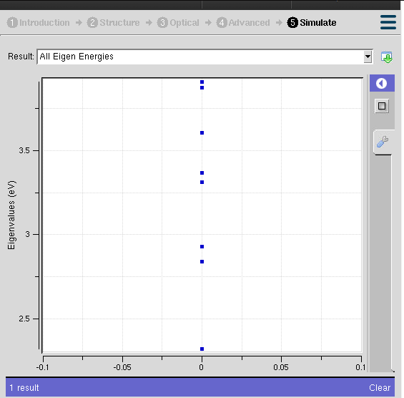

Case Study 1: Simulate the energy states of cylindrical quantum dots of X=15 nm, Y = 10.5nm and Z = 8nm.
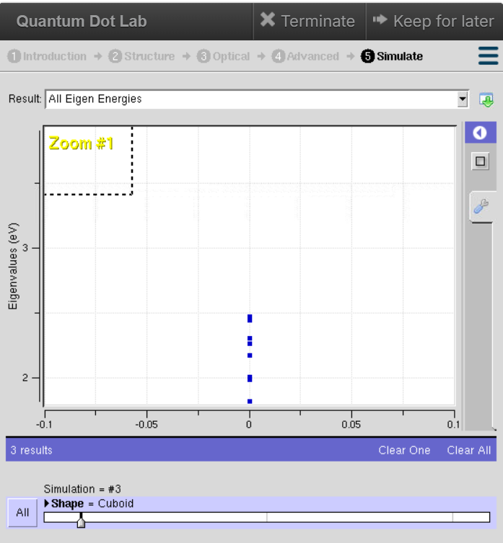

Observation
- The nano Hub simulation displays several discrete eigen energy levels, confirming quantum confinement inside the cylindrical quantum dot.
- The energy states are distributed approximately between 2.3 eV and 3.8 eV.
- Lower energy levels are closely spaced, whereas higher energy levels show comparatively larger separation.
- No continuous energy band is observed, indicating the presence of quantized energy states.
- The cylindrical geometry confines charge carriers in all three dimensions, resulting in well-defined allowed energy levels.
- The finite number of eigenstates indicates that only specific electron energies are permitted within the quantum dot.

Case Study 2: Simulate the energy states of two layer cuboid quantum dots
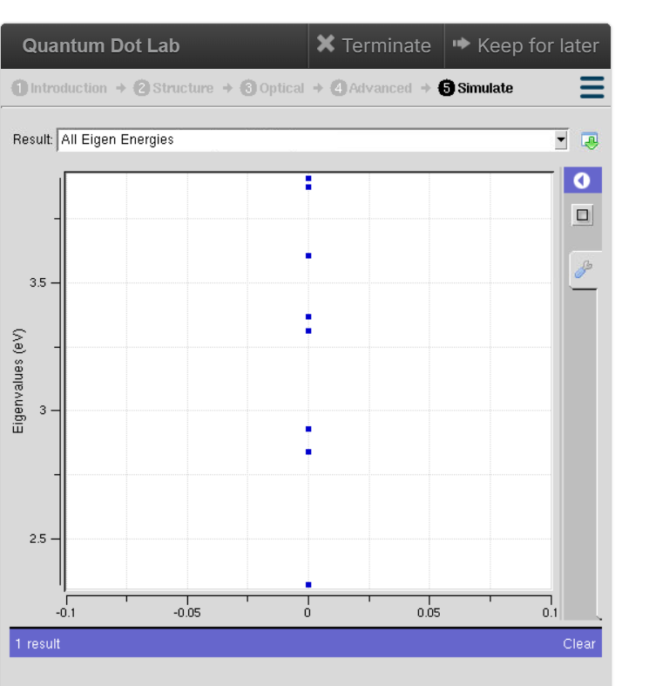
Observation
- The simulation produces multiple discrete eigen energy levels, characteristic of quantum confinement.
- The energy levels are observed approximately between 1.8 eV and 2.5 eV, which are lower than those of the cylindrical quantum dot.
- The spacing between adjacent energy levels is relatively small, indicating stronger interaction between the two quantum dot layers.
- The two-layer cuboid structure introduces additional confinement effects that modify the electronic energy spectrum.
- The energy levels remain discrete without forming continuous bands, confirming nanoscale confinement.

Conclusion
- The Nano Hub simulation successfully demonstrates the formation of quantized energy states in quantum dots due to three-dimensional quantum confinement.
- Both the cylindrical and two-layer cuboid quantum dots exhibit discrete eigen energies rather than continuous energy bands.
- The cylindrical quantum dot shows higher-energy eigenstates with comparatively larger spacing between levels, while the two-layer cuboid quantum dot exhibits lower energy states with closer spacing due to the influence of the layered structure.
- These results confirm that the shape, dimensions, and structural configuration of a quantum dot significantly influence its electronic energy spectrum, making quantum dots highly suitable for applications

Exp. 4. Kronig Penney Model
Aim: To simulate Energy functional vs Energy graph using Kronig Penney model

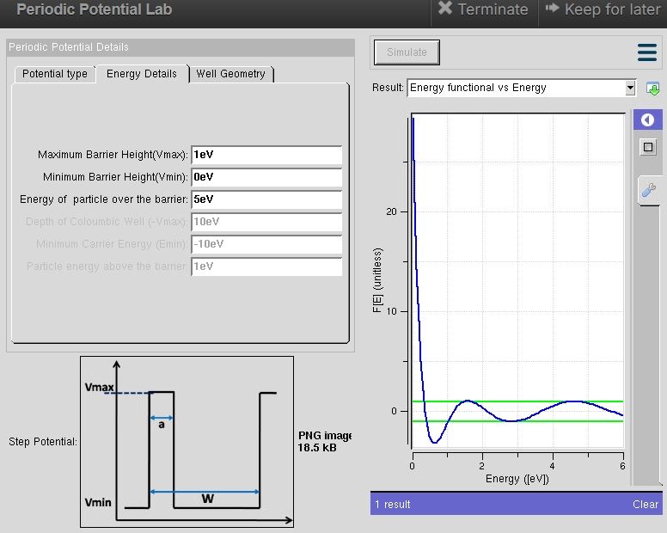Case Study 1: Simulate the output for Triangular well
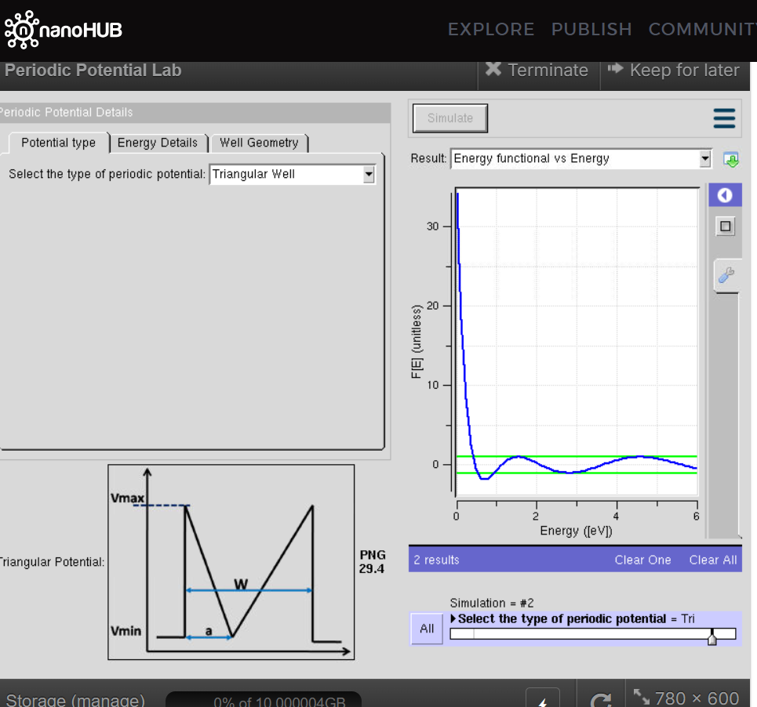

Observation:
- The periodic potential is selected as a Triangular Well.
- The Energy Functional varies non-linearly with energy.
- From the graph, the function shows a steep decrease at very low energy values followed by oscillations.
- The oscillations contain alternate positive and negative regions, indicating the periodic nature of the potential.
- As the energy increases, the magnitude of the oscillations decreases and the curve approaches the allowed energy region.

Case Study 2: Simulate the output for Sinusoidal Potential
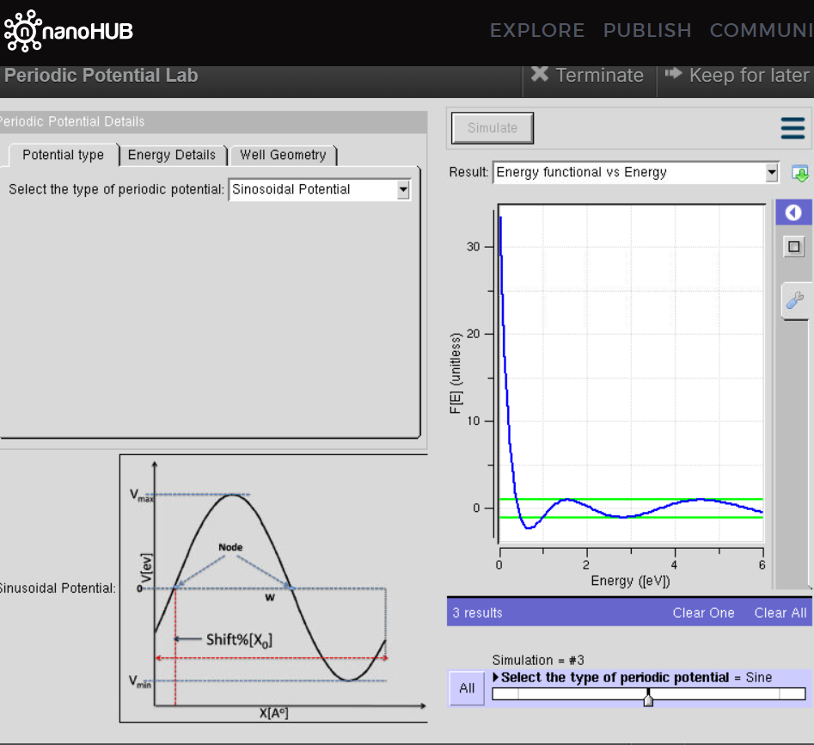
Observation:
- The periodic potential is selected as a Sinusoidal Potential.
- The Energy Functional initially decreases rapidly for low energy values.
- After the initial decrease, the curve exhibits periodic oscillations with positive and negative values.
- The oscillations become smoother as the energy increases.
- The sinusoidal potential produces a smooth periodic variation compared with the sharp variation associated with the triangular potential.

Conclusion
The Kronig-Penney model successfully demonstrates the effect of periodic potentials on the energy states of a quantum particle. The simulations for both triangular well and sinusoidal potential produce characteristic Energy Functional vs Energy curves with oscillatory behaviour. The results show that the shape of the periodic potential affects the distribution of allowed and forbidden energy regions. The triangular potential produces comparatively sharper variations, whereas the sinusoidal potential gives smoother periodic variations.

